User Acceptance Testing (UAT) Template
Date | 31 August 2026
Project Name | Automated Network Request Management in ServiceNow
Maximum Marks

Project Overview:
Project Name: Automated Network Request Management
Project Description:
A ServiceNow-based solution that allows users to submit network requests through the Service Catalog and automates request record creation, approval, processing, status updates, and email notifications using Flow Designer
Project Version: Version 1.0
Testing Period: 20 August 2026 to 25 August 2026
Testing Scope:
The UAT covers the major functionalities of the Automated Network Request Management system.
Features and functionalities tested:
- Network Request submission through Service Catalog
- Requester information capture
- Connection type and relocation details
- Device type and device details
- Dynamic field behavior
- Automatic request record creation
- Approval processing
- Request status update
- Email notification
- Network request record management
Requirements/User Stories covered:
- USN-1 – Request Submission
- USN-2 – Request Information
- USN-3 – Request Tracking
- USN-4 – Approval Management
- USN-5 – Team Assignment
- USN-6 – Workflow Automation
- USN-7 – Reporting
- USN-8 – Automatic Record Creation
Testing Environment:
Parameter | Details
Application | ServiceNow – Automated Network Request Management
Environment | ServiceNow Zurich Personal Developer Instance (PDI)
URL/Location | ServiceNow PDI
Credentials | Not included in documentation for security reasons
Browser | Google Chrome
Testing Type | User Acceptance Testing

Test Cases:
Test Case ID | Test Scenario | Test Steps | Expected Result | Actual Result | Pass/Fail
TC-001 | Network Request Submission | 1. Open Service Catalog.  2. Select Network Request.  3. Enter required information.  4. Submit the request. | Request should be submitted successfully and a request number should be generated. | Request was submitted successfully and a request number was generated. | Pass
TC-002 | Device Type and Dynamic Fields | 1. Select Device Type.  2. Select Others.  3. Enter additional device information. | The relevant additional field should become available when Others is selected. | The additional field was displayed as configured. | Pass
TC-003 | Automatic Record Creation | 1. Submit a Network Request.  2. Open the Network Database table.  3. Search for the submitted request. | A corresponding Network Database record should be created automatically. | Network Database record was created successfully from the submitted request. | Pass
TC-004 | Approval Processing | 1. Submit a Network Request.  2. Allow the configured Flow Designer workflow to process the request.  3. Review the approval action.  4. Process the approval decision. | The request should be sent through the configured approval process and the approval decision should be recorded. | Approval process was triggered and the request could be processed through the configured approval workflow. | Pass
TC-005 | Email Notification | 1. Submit a Network Request.  2. Allow the workflow to process the request.  3. Check the generated email notification. | An email notification should be generated with relevant request information. | Email notification was generated successfully with the request number and message details. | Pass
TC-006 | Request Status Update | 1. Process an approved request.  2. Update the request record.  3. Check the Work Status. | The request status should be updated according to the workflow. | Request status was updated successfully, including the configured Work In Progress status. | Pass

UAT Evidence – Test Execution Screenshots:
Figure 1: Successful Network Request Submission:
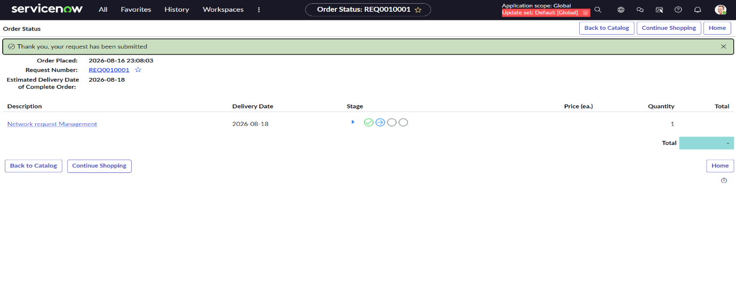Figure 2: Network Request Catalog Variables and Dynamic Fields
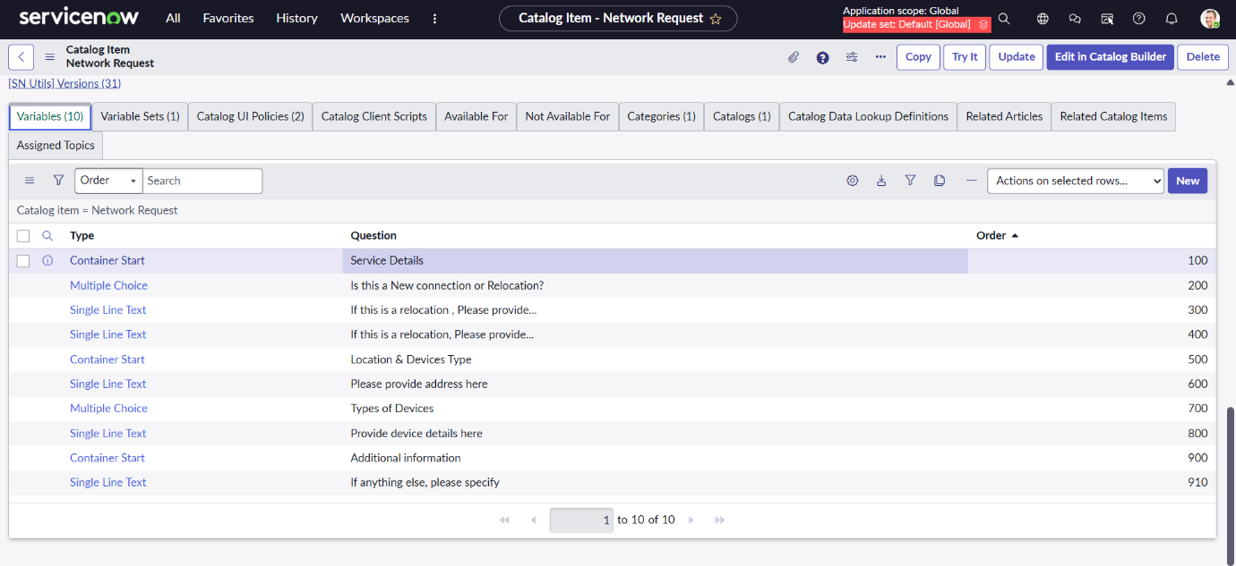
Figure 3: Automated Network Request Workflow
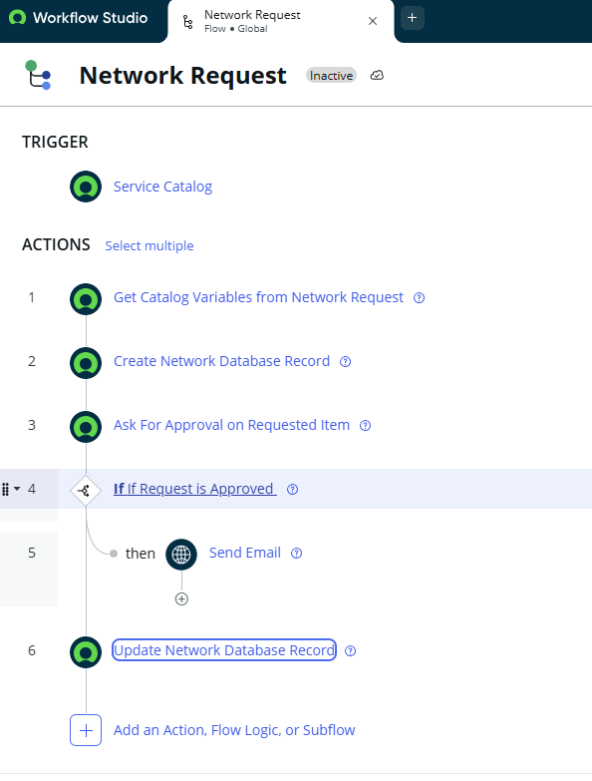
Figure 4: Email Notification Generated for Network Request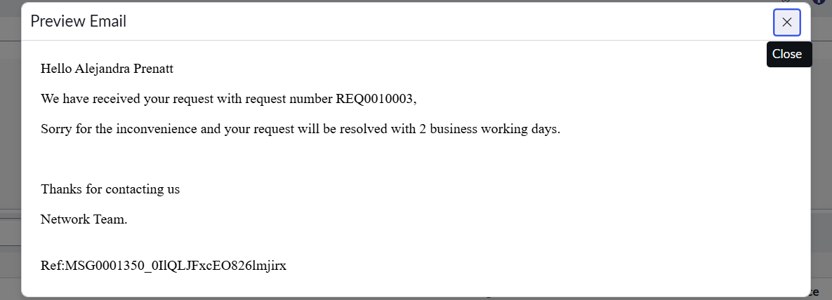
Bug Tracking:
Bug ID | Bug Description | Steps to reproduce | Severity | Status | Additional feedback
BG-001 | No critical or major defect was identified during the UAT scenarios performed. | Not Applicable | — | Closed | Core request submission, workflow automation, record creation, approval and notification functions worked as expected.

Sign-off:
Tester Name: Kancharla Dakshanya
Date: 25 August 2026
Signature: K. Dakshanya
UAT Conclusion:
User Acceptance Testing was performed to verify that the Automated Network Request Management in ServiceNow meets its key functional requirements. The testing covered request submission, dynamic fields, automatic record creation, approval processing, team assignment, status updates, reporting, and email notifications. All executed test scenarios produced the expected results, confirming that the core solution is functioning as intended and is suitable for project demonstration and evaluation.

